We want our ticket office to stay open to ensure the safety of passengers and to provide the service they need to meet their needs, especially those with disabilities and learning difficulties.
Note: This petition sheet will be shared with decision makers. Your details are being collected to validate the petition and verify signatures should it be required.
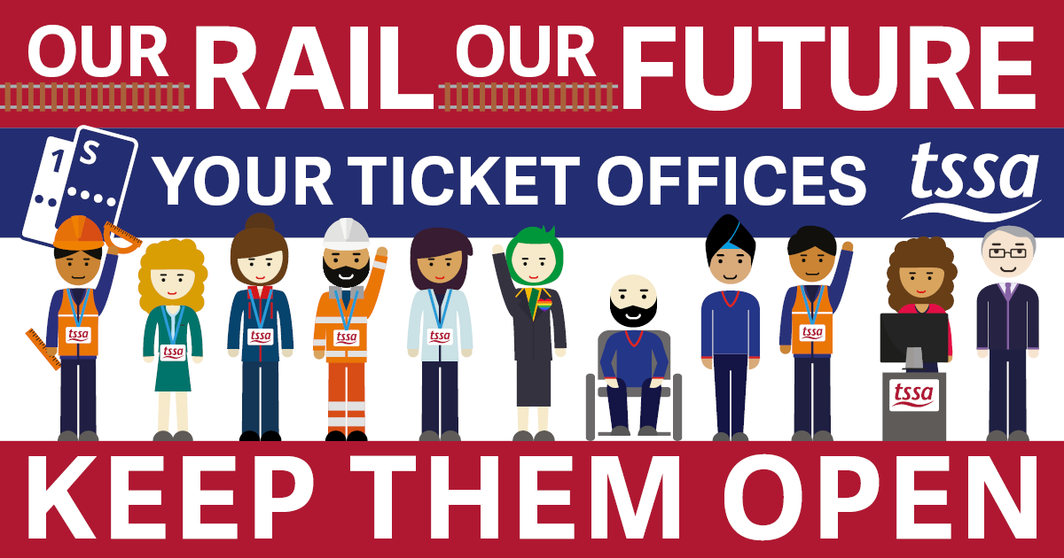
Name | Postcode | Email | Your  Ticket Office | Signature

We want our ticket office to stay open to ensure the safety of passengers and to provide the service they need to meet their needs, especially those with disabilities and learning difficulties.
Note: This petition sheet will be shared with decision makers. Your details are being collected to validate the petition and verify signatures should it be required.
Name | Postcode | Email | Your  Ticket Office | Signature

